Progress Report 2

Title: HTML/Javascript IT RPG Web Game

By: Ashlyn Mcconaha, [Dylan Wells Jones](mailto:dylanjones@arizona.edu), [Julia Ann Schaab](mailto:jschaab@arizona.edu)

**Changes to the Project:**

We have continued to develop our game further. Some changes include: adding code to incorporate movement and cutscenes for our scenarios to play out, creating different levels and room designs, and adding details into the webpage (such as the “about us” section and suggestions form).

**Technology:**

So far the largest portion of the technology is appearing to be JavaScript. We have found that it is quite capable of producing web games in addition to web development capabilities. We have also found some solid JS libraries that could help us create the vision we have for scenarios in the gameplay. We have been using the Aesprite software for level design and it has been very easy to use and learn. We anticipate that we can create several level ideas and choose the ones that best fit our game ideas (a few are included below). The webpage is created within Visual Studios by using HTML, CSS and a webform that will be incorporated with JavaScript.

**Team:**

We primarily communicate using Discord group chats and group calls. We are able to share the work that we have completed through our shared google document: <https://drive.google.com/drive/folders/1gIkLzZgiHYzVWrXovkNF-YW9Ei-O8MlH?usp=drive_link>

We also have created a Github that will house all of our final project files:

<https://github.com/amcconaha/APCV498>

We have been dividing the work so that everyone is able to contribute to the final results:

**The following is what each of the team members have been up to recently:**

Ashlyn: I have been developing scenarios for our game and creating level designs for Dylan to code into the project. My workflow so far has been to come up with an idea, create a simple map that would allow the user to play out the scenario and then describe the scenario so that we are able to add the dialog into a cutscene. Dylan showed me how to use the Aseprite software and I have been able to create the two scenes below. I have also created a file in our shared drive so that each member is able to construct their own “About Me” blurb to incorporate into the webpage. I have also begun working on my web form for my suggestions page. I created a logo for our group. Lastly, I have not started on the home page and levels page as I do not want to add details that will not make it into our game. (Additional Screenshots at the end of this document)

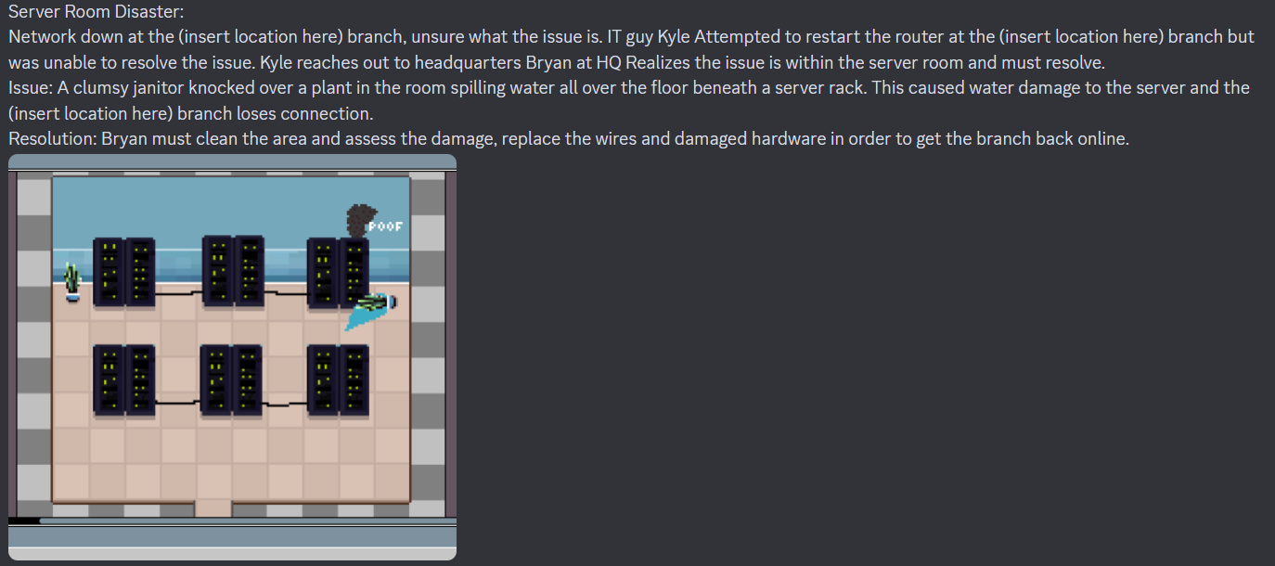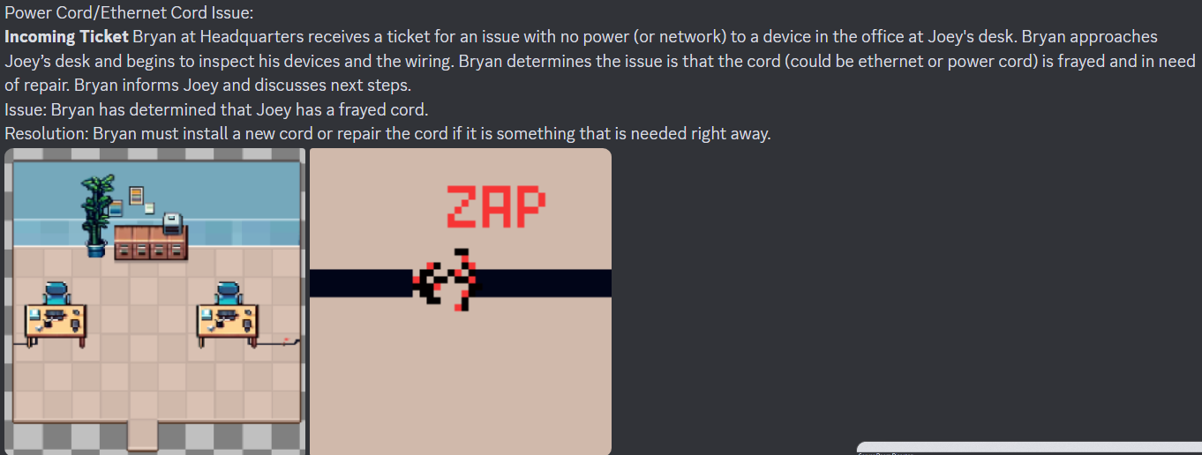

Dylan:

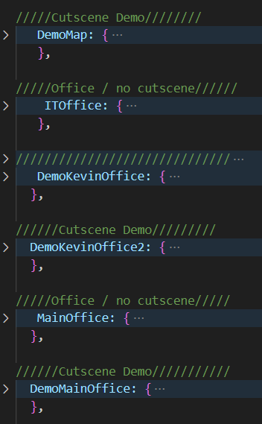

We have our building blocks for cutscenes, trigger points, and general character animations/interactions/dialogue set up. This will allow us to all begin to make the levels up to and following more advanced gameplay functions.

Julia:I am finally starting to understand how to create assets. I am starting to design some of the rooms for the scenarios. I am beginning to learn how the game logic works more and will start writing those instructions for levels I create. I am also planning out each scenario first so that I can then write the game instructions.

**The following is what we plan to accomplish before the next Progress Report:**

Ashlyn: I plan to have the suggestions form completely finished for the web page, create a few more possible scenarios to incorporate into the game and begin working on the walk through on the levels page.

Dylan: I am planning to build out more options in dialogue prompts, dynamic game objects such as interactable equipment, and the beginning of more complex game functions. We will be putting placeholders for any parts of levels where a function does not exist yet so that I can work on the functionality in the meantime and plug those things in later.

Julia:I plan to have the scenarios all written out step by step (or at least most of them). I want to at least have a few levels completed if possible. I will try and write the game logic for some of the levels as well. My main goal is to have one complete level done and to understand the code.

**Project Management:**

We have come a long way since our last progress report and have gained a lot more insight on what exactly we would like to accomplish moving forward. We have so far created the basic functionality for the game, the building blocks for the cutscenes, trigger points and character animations/interactions. We have collaborated on ideas for levels we plan to incorporate into the game and began building the maps that will host these in game interactions. The webpage contains the outline for the information, once that has been typed out and approved by the members of the group. Our timeline for the upcoming weeks is as follows:

Week 12 (March 31st - April 14): Begin working on our Progress Report 3, Continue working on game functionality and level creation, Add additional content to webpage.

Week 13 (March 31st - April 14): Submit our Progress Report 3 (April 8th), Finalize game and webpage, begin working on project poster and presentation (decide who will cover which information in presentation).

Week14 (April 14 - April 21): Finalize/Add finishing touches to our Project Poster and Presentation.

Week 15 (April 21 - May 3):Submit Project Poster and Presentation on April 22nd, Begin working on our Peer Evaluations and Submit Peer Evaluation (May 3), Submit Final Project (May 3)

**Reflection**:

We have been able to get a lot of work done in this short time from our first progress report and we look forward to the final product. We were able to meet twice this last week and work through a lot of the issues that we encountered. We were able to let each other know what was expected to be completed and establish the upcoming timeline (included above). Being able to see exactly how soon everything is due has motivated us to move quickly (and efficiently) in our development of the game and webpage. Dylan is our programmer for the project and when he runs into a bug, he will let us know exactly what is going on and how he plans to fix the issue. Oftentimes we get into a call to discuss other options should he not be able to work around the bug or if there is something that may be too complex for the little time we have remaining.

**Additional Screenshots**: Webpage details (not complete and under construction)

